**HND Computer Games Development**

**Graded Unit 2**

**Development Stage**

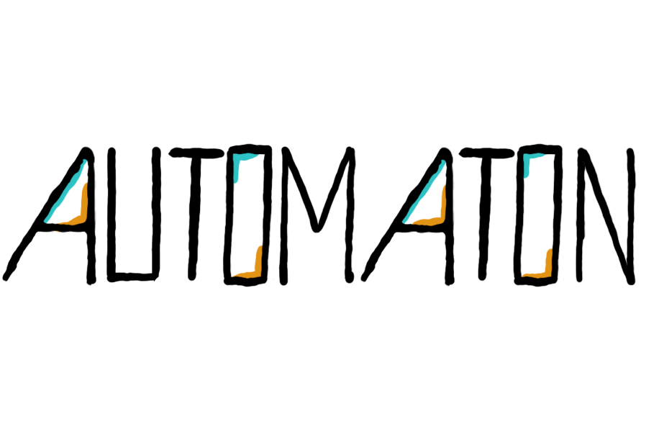

Media Catalogue

|  |  |  |
| --- | --- | --- |
| **Asset** | **Creation Type** | **Source** |
| Automaton Title (.PNG) | Self-created | Bridget Casey |
| Delta (model) | Self-created | Bridget Casey |
| Sigma (model) | Self-created | Bridget Casey |
| Bomb Cube (model) | Self-created | Bridget Casey |
| Energy Cube (model) | Self-created | Bridget Casey |
| Default Door (model) | Self-created | Bridget Casey |
| Orange Door (model) | Self-created | Bridget Casey |
| Blue Door (model) | Self-created | Bridget Casey |
| Wall (model) | Self-created | Bridget Casey |
| Floor/Ceiling (model) | Self-created | Bridget Casey |
| Floor – Wedge (model) | Self-created | Bridget Casey |
| Window (model) | Self-created | Bridget Casey |
| Notepad (model) | Self-created | Bridget Casey |
| Pedestal (model) | Self-created | Bridget Casey |
| Grapple Bar – Double (model) | Self-created | Bridget Casey |
| Grapple Bar – Single (model) | Self-created | Bridget Casey |
| Notepad (.PNG, Icon) | Self-created | Bridget Casey |
| HUD Crosshair (.PNG, Icon) | Self-created | Bridget Casey |
| Curved UI Mesh (model) | Self-created | Bridget Casey |
| Pop sound effect (audio) | Outsourced | https://www.youtube.com/watch?v=LnMhJU6RsYU |
| Footsteps on cement (audio) | Outsourced | http://soundbible.com/2057-Footsteps-On-Cement.html |
| Grappling hook free sound effect (audio) | Outsourced | https://www.youtube.com/watch?v=iz3lZZyqzbQ |
| Robot blip 1 (Audio) | Outsourced | http://soundbible.com/1682-Robot-Blip.html |
| Robot blip 2 (Audio) | Outsourced | http://soundbible.com/1669-Robot-Blip-2.html |
| Eon – Ambient Sci-Fi Music (Audio) | Outsourced | https://www.youtube.com/watch?v=XVbvE0PJyss |
| Ambient Sci-Fi background music (audio) | Outsourced | https://www.youtube.com/watch?v=HIdNZlBKrTA |